REGEX ONLINE TRAINING PYTHON ASSIGNMENTS

ASSIGNMENT 2 :

Answer 1 :

TO PRINT A NEW LIST CONTAINING ALL FIRST LETTER OF CHARACTERS INSIDE A GIVEN LIST

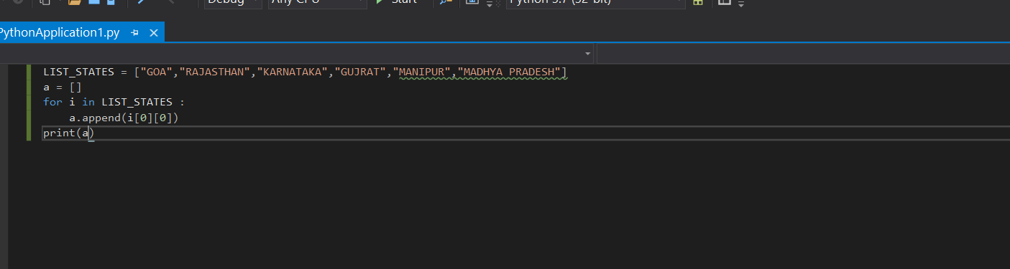

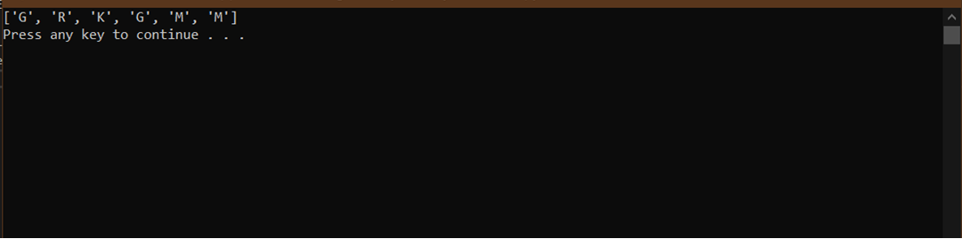

Answer 2 :

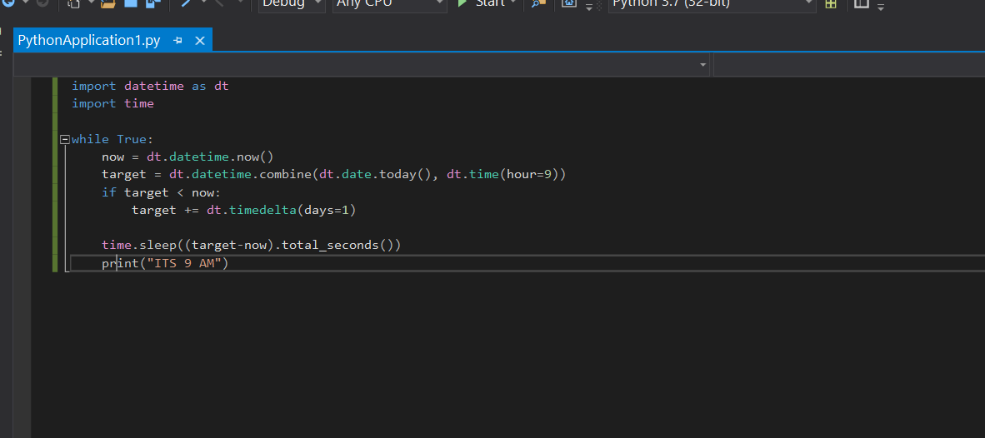

Answer 3 :

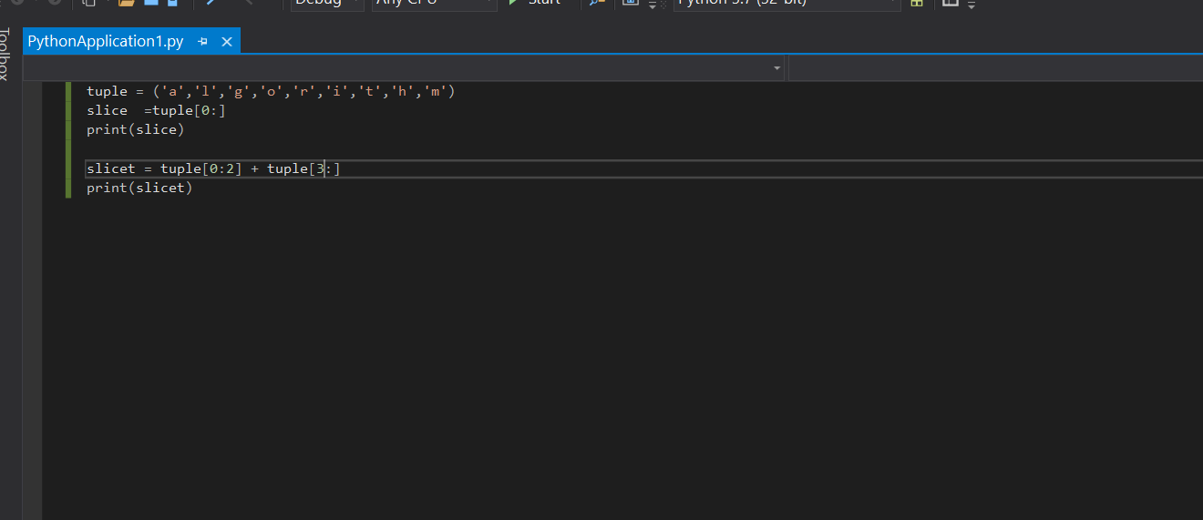

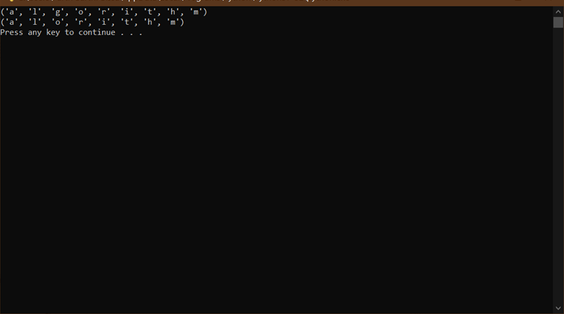

Answer 4 :

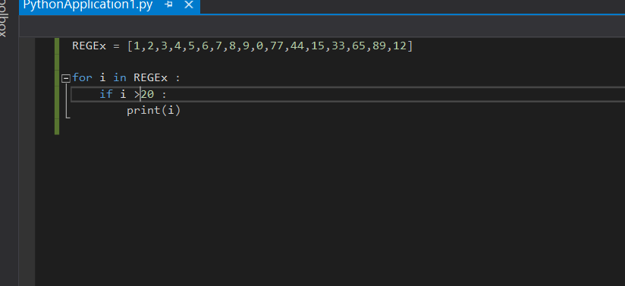

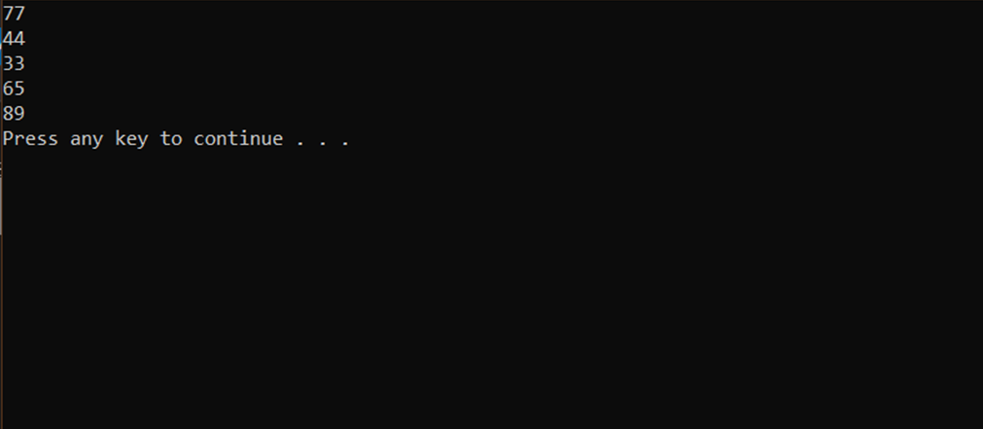

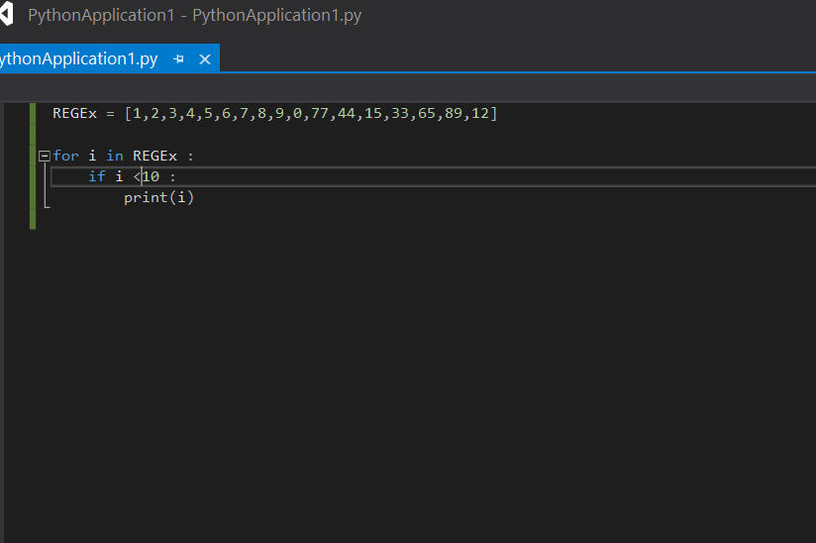

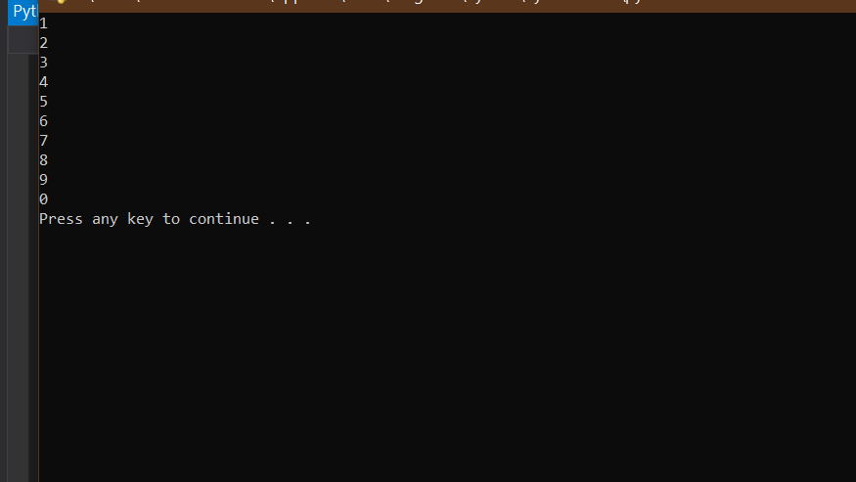

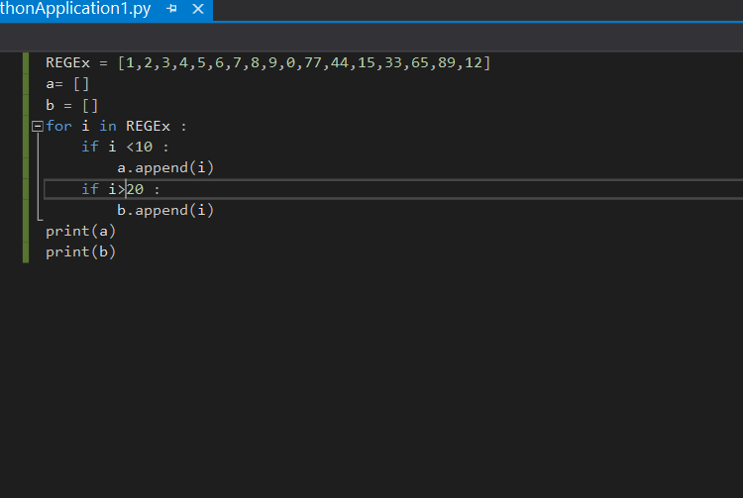

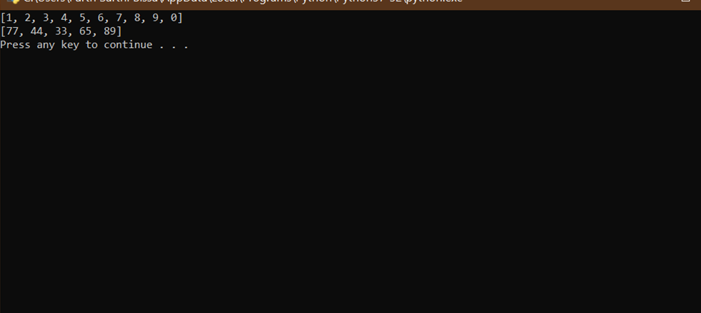

Answer 5 :

Using os module in python we can run the linux command through a python program like :

import os

os.system(“date”)

For running date command of linux using python

Answer 6 :

\*args = The special syntax \*args in function definitions in python is used to pass a variable number of arguments to a function. It is used to pass a non-keyworded, variable-length argument list.

\*\*kwargs = The special syntax \*\*kwargs in function definitions in python is used to pass a keyworded, variable-length argument list. We use the name kwargs with the double star. The reason is because the double star allows us to pass through keyword arguments (and any number of them).